Name : | Mrunali Jibhakate | Class/roll no : | 6th EE B - 107
Reg. No : | 23071350
Aim : | To perform data cleaning and implement categorical data encoding techniques, specifically Label Encoding and One-Hot Encoding, on a Titanic passenger dataset using the Python pandas and scikit-learn libraries.
Implementation Steps : | • Step 1: Dataset Loading  • Step 2: Handling Missing Values  • Step 3: Label Encoding (Ordinal Data)  • Step 4: One-Hot Encoding (Nominal Data)  • Step 5: Data Concatenation
Program Code : | import pandas as pd  from sklearn.preprocessing import LabelEncoder  # 1. Load dataset  df = pd.read_csv('titanic_dataset.csv')  # 2. Handle Missing Values  df['Embarked'] = df['Embarked'].fillna(df['Embarked'].mode()[0])  # 3. Label Encoding for Pclass  le = LabelEncoder()  df['Pclass_Label'] = le.fit_transform(df['Pclass'])  # 4. One-Hot Encoding for Embarked  df_embarked_onehot = pd.get_dummies(df['Embarked'], prefix='Embarked')  # 5. Combine and View Result  df_final = pd.concat([df[['PassengerId', 'Pclass', 'Pclass_Label', 'Embarked']],  df_embarked_onehot], axis=1)  print("--- First 5 rows of encoded data ---")  print(df_final.head())  2) # Cleaning up for the model  df_model = df_final.drop(['Embarked'], axis=1)  df_model
Output : | 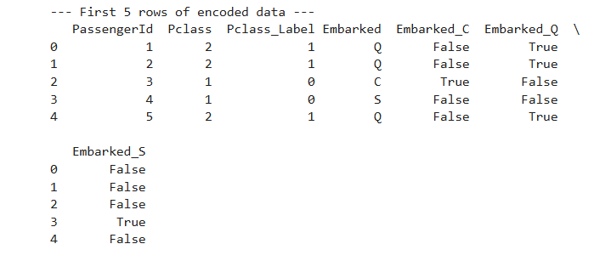  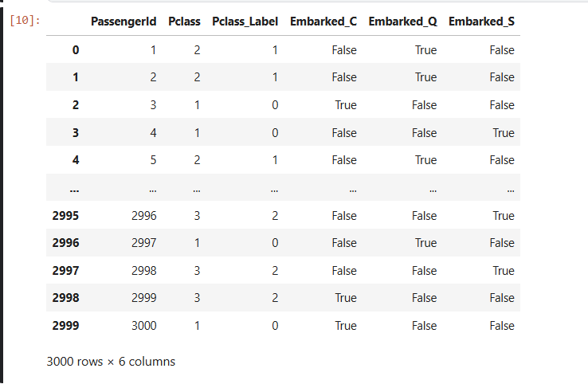
Result : | Successfully implemented data preprocessing on the Titanic dataset. We concluded that Label Encoding is suitable for features with an inherent order, while One-Hot Encoding is essential for categorical features without a specific ranking to avoid bias in model training.

Marks : |  | Name of Lecturer : Dr. S.A. Dhondse
 |  | Signature :

